**DAILY ONLINE ACTIVITIES SUMMARY**

|  |  |  |  |  |  |  |  |  |
| --- | --- | --- | --- | --- | --- | --- | --- | --- |
| **Date:** | **07-6-2020** | | | | | **Name:** | **Likhitha.M** | |
| **Sem & Sec** | **6th sem ‘A’** | | | | | **USN:** | **4al17cs046** | |
| **Online Test Summary** | | | | | | | | |
| **Subject** | | **System Software and Compiler Design** | | | | | | |
| **Max. Marks** | | **30** | | **Score** | | | **23** | |
| **Certification Course Summary** | | | | | | | | |
| **Course** | **Introduction to Ethical Hacking** | | | | | | | |
| **Certificate Provider** | | | **Great learning** | | **Duration** | | | **3 days** |
| **Coding Challenges** | | | | | | | | |
| **Problem Statement:**  1.write a java Program to print smallest and biggest possible palindrome word in a given string  2. Python program the first and last 5 elements  Description: Print a list of first and last 5 elements where the values are square of numbers between 1 and 30 (both included)  Eg: If the range of elements is 20 Then output is: [1,4,9,16,25] [256,289,324,361,400] If the elements begins from 5 to 30 Then output is: [25,36,49,64,81] [676,729,784,841,900] | | | | | | | | |
| **Status: completed** | | | | | | | | |
| **Uploaded the report in Github** | | | | | **yes** | | | |
| **If yes Repository name** | | | | | **https://github.com/likhithaMantaral/Daily-status** | | | |
| **Uploaded the report in slack** | | | | | **yes** | | | |

Online test Details:

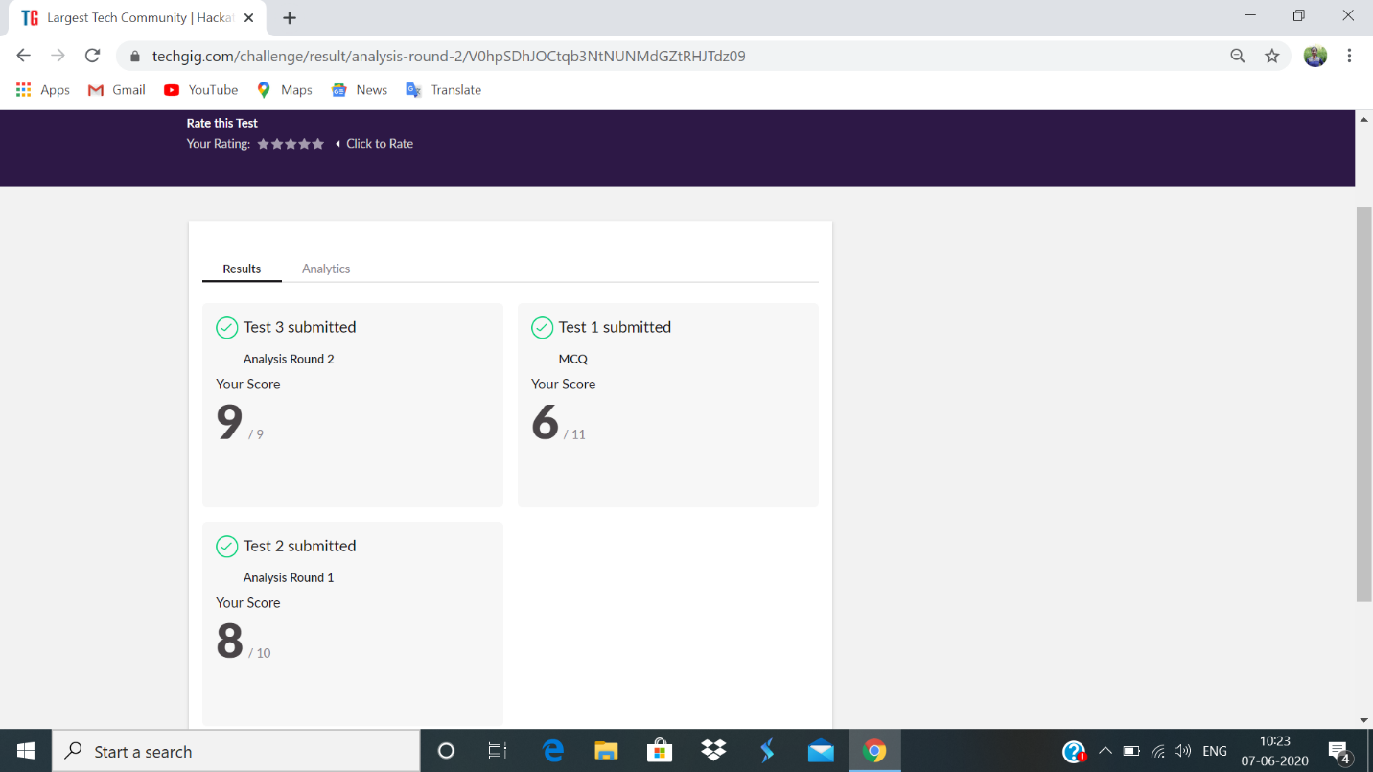

Certification Course Details:

**Introduction to Ethical Hacking**

**Career and growth ladder in Ethical hacking:**

Security market outlook- cyber security expenditure, cybercrime cost.

Roles related to Ethical hacking:

Information security analyst, Cyber security analyst, security engineer, security analyst, Information security manager, Cyber security engineer, security consultant.

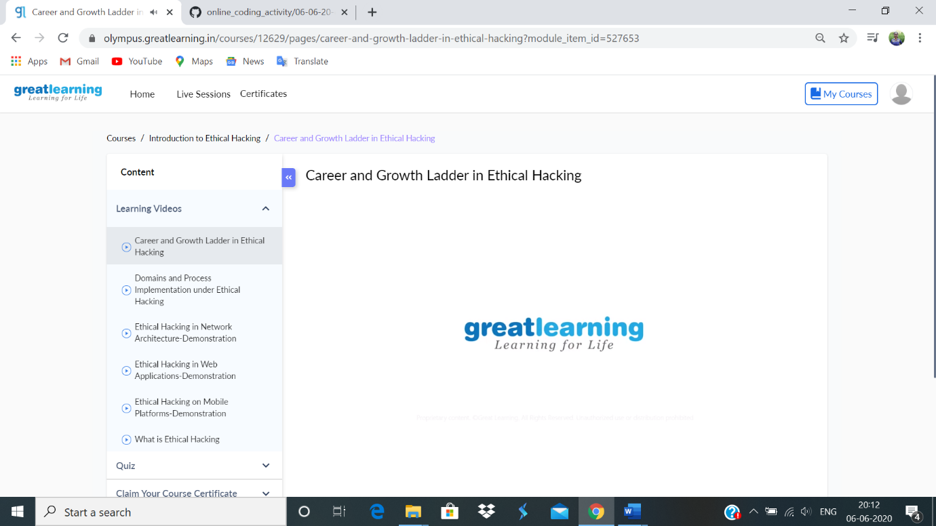

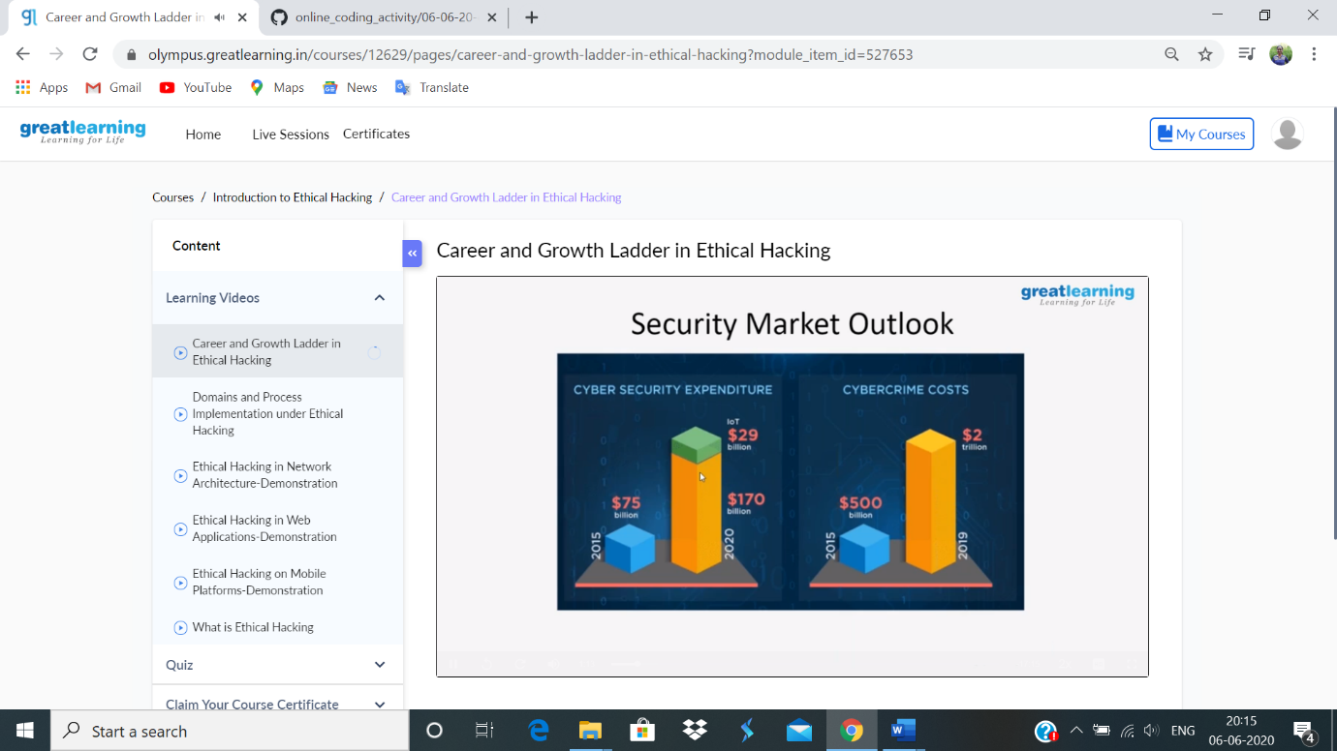

**Coding challenge:**

**1.**

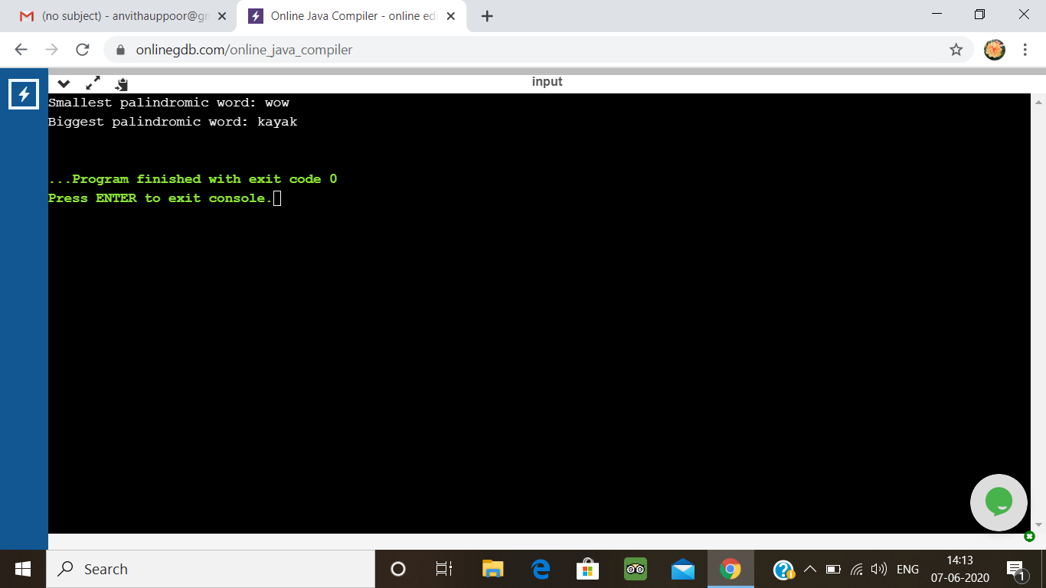

2.

